
Small business management

Task 2-Design Folio

Due: Friday 23rd March





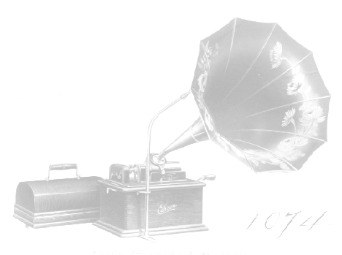

Kara Hewitt

Technology process

Investigation:
Sarah and I have been investigating photography, in small business. We are going to work at the year 9 social, taking photos and then selling of to the students who are interested. Kara and I will be investigating, the following.
• If we are going to use a Polaroid camera, or digital
We have re-searched
• What sort of background we want
• How we want to present the photos
• How much we want to sell the photos.
• We are investigating, other professional photographers and how they present
Their photos. To do this we re searched internet sites of photographers we were
Familiar off and see how they set up and structure their photos
• We are investigating, the costs of the material we need and how much we will
need to sell the photos for in order to make our money back. How we investigated
this is we Re searched our ball photo prices and see what sized he priced for
the photos

- Craig Stewart photography – photographs balls, head shots, full body shots, group shots, couples, single shots. Has many different backdrops. More than one person taking photos at a time.
- Steve’s photography – experienced photographers, choice of backdrops, more than one person taking photos at one time,
- Polaroid camera or digital or film camera??
- Cost? Craig Stewart charges $7 for a standard photograph to be printed
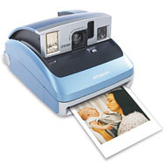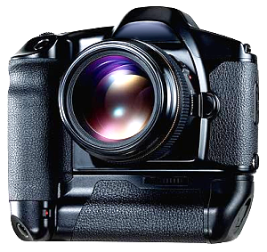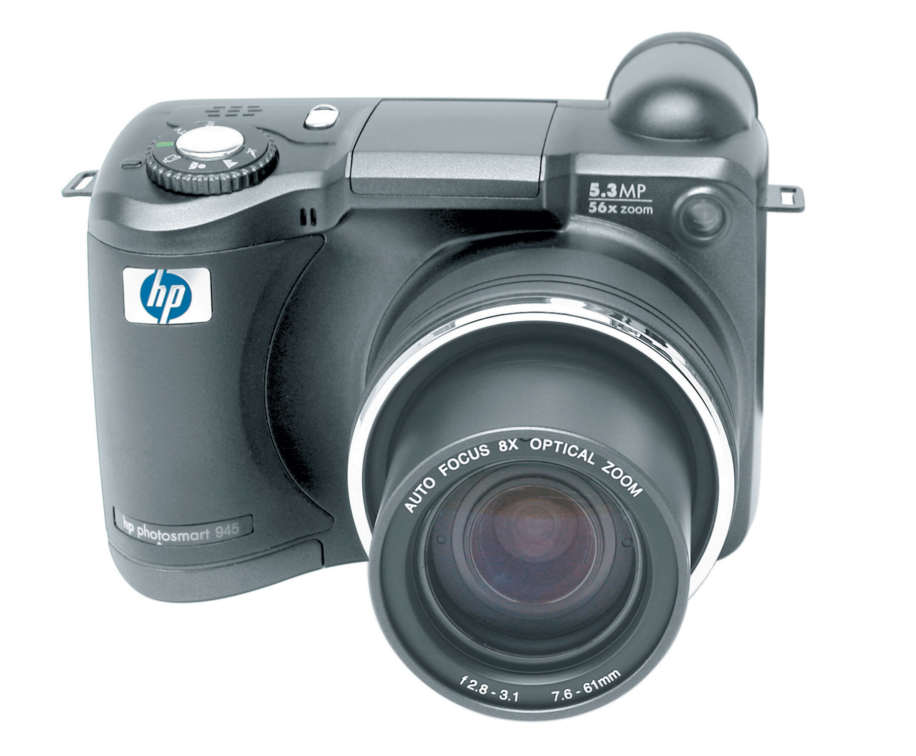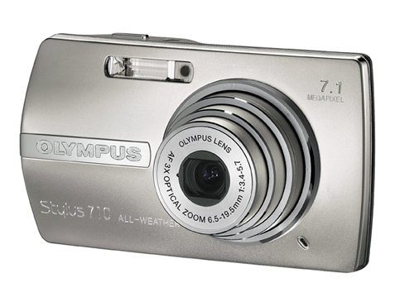

Technological:
- Discus camera type
- Camera quality
- Mega pixels
- Print size
- Image size
- Image types
- Computer being used- fast or slow?

Environmental:
- Save the forest
- In the old days, cameras did not show what they had taken until the photos were printed and so many people received half the photos of which they did not want or need. This was a small but relevant issue when it comes to wasting paper
- Also when cameras used chemicals when developing that hurt the environment, now the camera just needs to be connected to the computer.

Social factors:
- Benefits of photography
- benefits of record keeping for parents and other family or friends
- social reference, people can share and be proud, and reminisce
- Year books, helpful when the school is putting together the year books at the end of the year

Health and safety:
- Care with equipment
- Tripod
- Cables
- Leads making sure people don’t fall over
- Health with taking photos, bending over a lot.
- Put up posters, making sure you don’t fall over any equipment.

Analyses:
- Researched photographers on internet
- Asked peers what prices should be
- Look at the survey that the kids answered
- Research the theme of the dance and use it in the photos somehow

Make predictions:
- Will we make any profit?
- I think that our business will be very successful and we will make a profit.
- Our photos will be very popular any most of the students will be interested and buy them.
- All of our work will be completed the night of the social, and no chasing up of students will be necessary

Devising:
How we going to do it, we first will organise our equipment, what we are going to use and need eg: digital cameras, printers photo paper etc: We then will set up our background, making sure that its stable and safe and doesn’t get in the way of the stage etc. then we will use all the information we have gathered and researched and produce the product.

Producing:
To produce we must:
- Get all information needed and understand the task needed to do
- Get permission to take photos at the social
- Permission to charge
- Ask how much we should charge
- Research cameras and possible ideas for taking photos
- Put all information together
- Show teacher and get approval

Evaluation:
Did we make a profit?
Did we make the kids happy?
Did we complete the task effectively?
Are we happy with the process and outcome?

.

Outcome 2: Evaluates health and safety practices in a variety of small business enterprises.
- Health and safety will be a big factor on the night of the social and concerning any night for it is always a relevant issue, for example at the dance, it will be relatively dark and many cords and objects will be around the area, so we must ensure that we make that space as safe as possible. Also there are many people going to be dancing and having a good time so they wont be paying attention to who they bump into and they may trip over and hurt themselves, also if there is food and drink at the social there may be chances that some kids will spill food and rink and others can slip on it and hurt them self.
- There are many dangers that are associated with children and teenagers because they are very active and sometimes can be irresponsible and not be aware of the dangers surrounding them. These can be avoided by taking necessary precautions to ensure the safety of the children such as cleaning up rubbish that people could trip or slip on and tiding up cables that people can trip on.

Outcome 3: Locates and uses suitable information to formulate decisions for small business enterprises.

- Nine out of 10 businesses in Australia are small businesses and 6 out of 10 new jobs that are created come from the small business sector. It is interesting to note that women are opening small businesses at twice the rate of men. Currently, 32 per cent of all small businesses across Australia are owned and operated by women. Each year, 37 per cent of employed women choose to leave and open their own small business venture. Flexibility, creativity and earning what they are worth are some of the many reasons women give for leaving employment to commence their own business.
- http://www.womensnetwork.com.au/library/smallbus/running.htm


  - People acquire small businesses in many ways, but all are faced with one common challenge: taking charge of everything involved in running a business. Running a small business involves many activities, including developing a business plan, overseeing sales and marketing, dealing with personnel and a whole range of administrative responsibilities. While the list of tasks seems daunting, even overwhelming, you can start by breaking the job into its components. By reviewing some of the main pieces, you may find it more manageable.
  - http://www.metlife.com/Applications/Corporate/WPS/CDA/PageGenerator/0,4132,P2270,00.html
  - Running a successful small business is about doing things a little differently from that of your competitors. These little differences can be enough to capture business from your competitors, attract new customers and bring so much money into your business that you won't know what to do with it all. What a great problem that would be!
  - http://www.smallbusinesssuccess.biz/

  - DEBUNKING SELF-EMPLOYMENT MYTHS
1. "it is less secure to work for yourself than to have an employer"
This one is easy- you have been paying attention the last 25 years, haven't
you? There is absolutely zero security in working for someone else. Many of
my friends have been out of work for two years now. I haven't missed a
pay check. They've been of wildly varying sizes, but in 25 years I've never
gone hungry or had to borrow rent money.

2. Must be a super-sales ace
Nope, not at all. For some reason when I say "work for yourself" the first
thing people envision is going door-to-door, suffering rejection and abuse.
Don't do that- we'll talk about how to generate business the fun, natural way.

3. You need bank loans to get started
Nuh uh. Don't borrow money to get started.

Here is lesson #1: Decide what you want to do.
This is the hardest part for many people- they just don't know what they want
to do.

Try approaching this from the perspective of what are your true desires? What
is your true calling? What brings you joy? What challenges you? Put aside all
thoughts of what you can do to make money- don't even think about money at
this stage. When you start from 'how can I make money' you get all syce
up and do unfulfilling things.

It doesn't matter how old you are, or what your existing skill set and
Experience consists of. What Do You Really Want To Do?

Don't think 'What Should I Do?' That's crap, that's baggage that holds people
back.

*Taken straight from the internet site below.
- http://mailman.linuxchix.org/pipermail/courses/2002-August/000719.html

- Anyone with the right camera equipment and the necessary skills can set up a home business, marketing photography. You need only to convert a room of your house into an office, and then you can work immediately.
With modern technology in the form of SLR digital cameras, you do not even need the room for a dark room. You need only to have a personal computer and a photo-editing program. The standard is Adobe Photoshop.
It is not necessary to clutter yourself with equipment you do not need. You can hire equipment on and when you need it basis. You have the freedom to work part time for a while until you can devote yourself full time to photography. All you need to be is a serious photographer. There are two types of photographers that makes their living from photography, the serious photographer and the very serious photographer. You can always bookmark this link and then you can quickly access just about all you'll ever need from here.
Whilst the technical skills needed to make a successful photographer have never been easier, other aspects have changed the business. The market for photographs of virtually every type has widened, the world seems to have an insatiable appetite for photographs. However the price has fallen as the marketing net has broadened. Photographers are needed in many more fields. For instance many people use car web sites, they simply did not exist ten years ago, and they sell their products as a result of photography. Cameras used by scuba diver’s are now an excellent quality, and whilst they are initially expensive, they have forged a new market. People celebrate special occasions more with photography, than they did years ago. The travel and advertising markets have a greater need for landscape, travel and nature shots.
*taken straight from the internet site below. Photography- may help our small business for photography at the year 9 social.
- http://ezinearticles.com/?Start-Your-Own-Photography-Business-from-Home&id=67905

- There are few things more fulfilling in this world than to do exactly what you want to do, like getting paid for it. Those who enjoy photography as a hobby can start a photography business and get paid to do what they enjoy.
- Starting any business, however, requires more than a skill, but also business sense, research and thorough planning on the entrepreneur's part, including research on location, local competition and pricing.
- Creating a portfolio of terrific pictures is one way to attract prospective clients and investors. Press releases and public relations are another way to spread the word about your start-up photography business.
- After a business plan is created, seeking capital to start up the photography businesses is important. Angel investors, private investors and venture capitalists are always available options in assisting entrepreneurs with financing businesses. A venture investor will look for promise and skill in the goals and abilities of the entrepreneur.
- Take the Venture Worthy survey to find out more about starting a photography business.

- http://www.ventureworthy.com/Starting-a-Photography-Business.asp

- Analyses your examination, scrutiny, testing, investigation and findings analysed by your own opinions or research)
- http://www.gittings.com/home.jsp
- GITTINGS
“For 80 years the Gittings studios have been synonymous with exceptional portraiture. We have studios in 3 Texas cities, and have served thousands of families throughout Texas and the South. Gittings has photographed all US Presidents”
- Advantages:
    - Family portraits, children’s portraits, executive portraits
    - Expert advice
    - Event photography
    - Galleries
    - Many different locations

- Disadvantages:
  - This company is in Texas
  - Only does portraits, no weddings or balls etc
  - Business doesn’t have any important awards

Outcome 5: Uses appropriate technologies for small business.

I used the following technology, computer with Microsoft office, internet explorer, both of these will be ideal in a business environment because they are simple and efficient and easy to use plus they are common programs across the entire business network. The computer I used was provided by the school and is a ‘IBM’ I also used a USB to transfer information from home to school.

Outcome 6:

DEFINING SMALL BUSINESS
For the purposes of this publication a small business is defined as a business employing less than 20 people. Categories of small businesses include:
- non-employing businesses - sole proprietorships and partnerships without employees;
- micro businesses - businesses employing less than 5 people, including non-employing businesses;
- other small businesses - businesses employing 5 or more people, but less than 20 people;
Business continuity is relatively easy for large enterprises. They have the IT staff and the deep pockets to be able to spend millions of dollars implementing redundant data centres, instantaneous mirroring of all information and a host of other disaster recovery technologies.
Is there a new face of Australian small business? If so, what does it look like?
Nearly half the small businesses in operation in Australia today started in the past six years and in the past decade they've provided four out of five of all the new jobs created. Small businesses employ around 40% of the workforce, and are responsible for generating around a quarter of our GDP. Small businesses employ nearly half the Australian workforce. Business is really important to the economy because with out any small businesses people would be out of work and many of the things that are available would not be available.
http://www.abc.net.au/rn/learning/lifelong/features/smallbiz/

Business Plan Proforma

Description of the Business :
Sarah and I are starting a small business called Sarah and Kara photography. To start of this business we will be setting up a photo shoot for the year nine students at there annual social. Our business will include individual photos and group. We will have backgrounds and computers for the photos to be transferred on to so that the customers can have there photos shortly after we take them.

This is a requirement for out year 12 small business management class

The opportunity for this business is to make the kids happy and make a profit, this business exist for the children to enjoy and to make profit. The industry trends at this current time are: photos are very popular with this generation of children because of the easy access to cameras and computers and also the new technology of digital cameras, so this business will be very successful. Because photography is very popular there are many competitors but none at our school or that will want to do the year 9 social so at this time there is no need to worry about competitors.

The target market are the year 9 students of corpus Christi college at this time, unless this business was continued to other schools or other year groups, this task allows us to focus on one year group.

The financial assistance we will require is the schools funding of paper and ink for printing the photos, also the back drops, but we may be able to find them somewhere and wont have to spend any money, and also the possibility of hiring cameras?

Financial Projections. Summarise sales projections and profitability:

Anticipated cost of paper approximately $35 per 100 sheets = .35 cents per page. Ink, 2 cartridges total cost $90 = $180 + $35 = $215

Total sold Anticipated 100 at $5.00 = $500

$500 - $215

Approximated profit = $285

THE BUSINESS AND ITS MANAGEMENT

1.1 THE BUSINESS CONCEPT

1.1.1 Business Type
Photography of students at the year 9 social.

1.1.2 Products / Services
our products will be portraits of people and our service will include any group of people or individual, also we will print the photos shortly after they are taken so the customer will not have to wait for the photos to be developed and we wont have to chase them up for money or to give them there photos.

1.1.3 Major Customers
Year nine students at corpus Christi college.

1.2 LEGAL AND ADMINISTRATIVE REQUIREMENTS

1.2.1 we needed to write a letter to the head of year 9, the man organising the social(event) and ask if we could sell our products at the social. Also our teacher needed to ask the principle if we could make a profit of the students.

1.2.2 Insurance
We investigated if public liability is used for this event.

1.2.3 Restrictions / Requirements
Some restrictions will be the cost. Because we aren’t professionals we cannot charge as much as
They do and also we must produce a good product and require to live up to our expectations that the kids have been told.

1.3 TRADING NAME

1.3.1 Description
Our trading name is ‘Kara and Sarah photography’ or K.S. photography, we chose this name so it is easy to understand and quick and straight to the point. It also allows customers to know our names.

1.4 LEGAL STRUCTURE

1.4.1 Description
Sarah and I are running a small partnership business.

1.4.2 Legal Implications
We need to check with the school, and check for public liability.

    - Tax Implications
-

1.5 BUSINESS PREMISES

1.5.1 Details
There is no past business this is our first.

    - Alternative Sites
We cannot fall through because we are the only business that is doing photography and we must provide a solid photography business for the social.

1.6 STAFFING AND ORGANISATION

1.6.1 Key Roles
Sarah and Kara: photography
Ashleigh and Sarah Bell: music/audio (music, Dj, sound systems etc)
Tara and Ben: graphic design, (posters, tickets etc)
Sophia: treasurer ( finance)
Emma: sectary, ( records data at meeting etc)
Michael: chairman
Laughlin: public relations

1.7 OCCUPATIONAL HEALTH AND SAFETY

1.7.1 Occupational Health and Safety Responsibilities
We have to consider the health and safety of the students attending the social. We must take all precautions and assure the night runs smoothly.

1.7.2 Current / Potential Hazards
Cords that people can trip on, tripods getting in the way, children could brake cameras if they pick them up or they can trip on backdrops etc.

1.7.3 Procedures / Policies
We must set up our business and run through all possible situations and make sure all safety restrictions are met.

  - IMPACT OF TECHNOLOGY

    - Technology Used
Computers
Lap tops
Digital cameras
Flash
Photoshop
printers

    - Impact
A big impact will be the use of digital cameras because they will be so much better then film and now we can give the photos to the children much quicker than if we had to wait for them to be developed.

